Peer and Self Review

|  | P1 Sophia | P2 Haoxuan | Self |
| --- | --- | --- | --- |
| Project Quality | 1 | 1 | 1 |
| Input | 1 | 1 | 1 |
| Create, Read, | 1 | 1 | 1 |
| Update, delete | 0 | 0 | 0 |
| Individual code quality, review and observe comments | 1 | 1 | 1 |
| BE review, observe if Individual API handles error conditions | 0 | 0 | 1; no conformation page is shown if a blank submission is attempted |
| BE review, observe if Individual API contains GET and POST methods | 1 | 1 | 1 |
| BE review, observe that Individual code contains database operations that support Create, Read | 1 | 1 | 1 |
| BE review, observe that Individual code contains database operations that support Update, Delete (above requirement) | 0 | 0 | 0 |

Evidence of Requirements

Link to video demonstration of project: <https://www.loom.com/share/ff02b8538267459f9a4dfc420c69c04a>

**Input:**

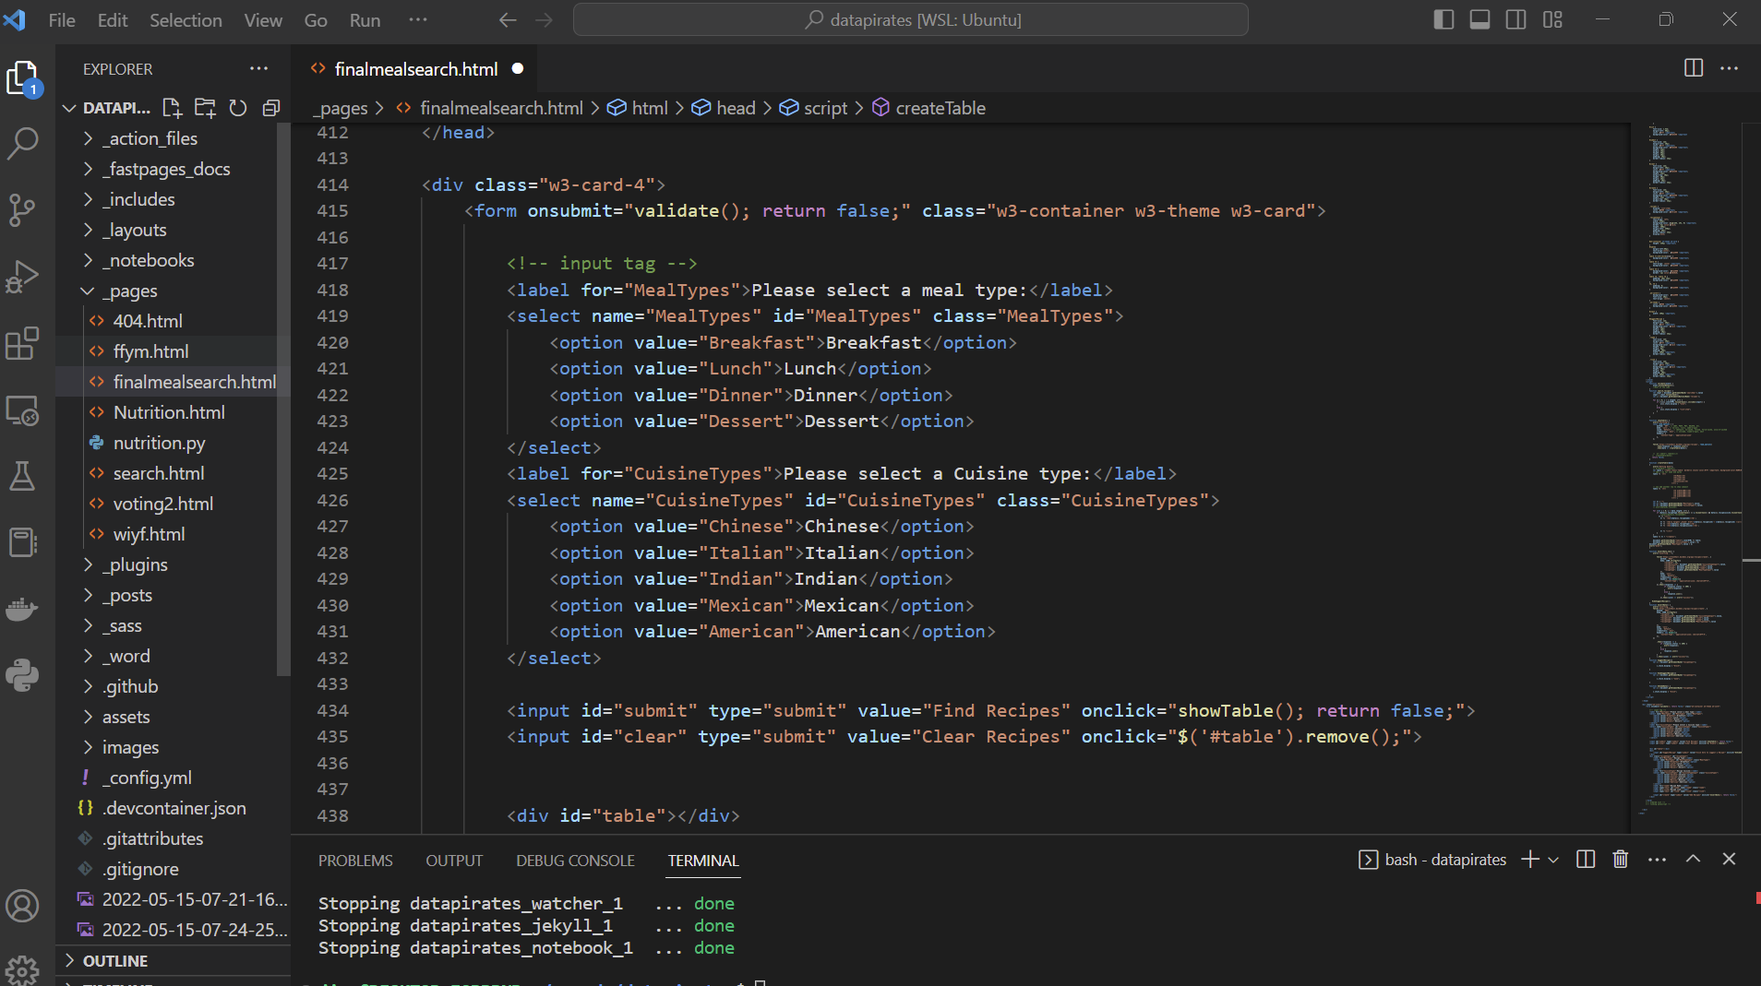

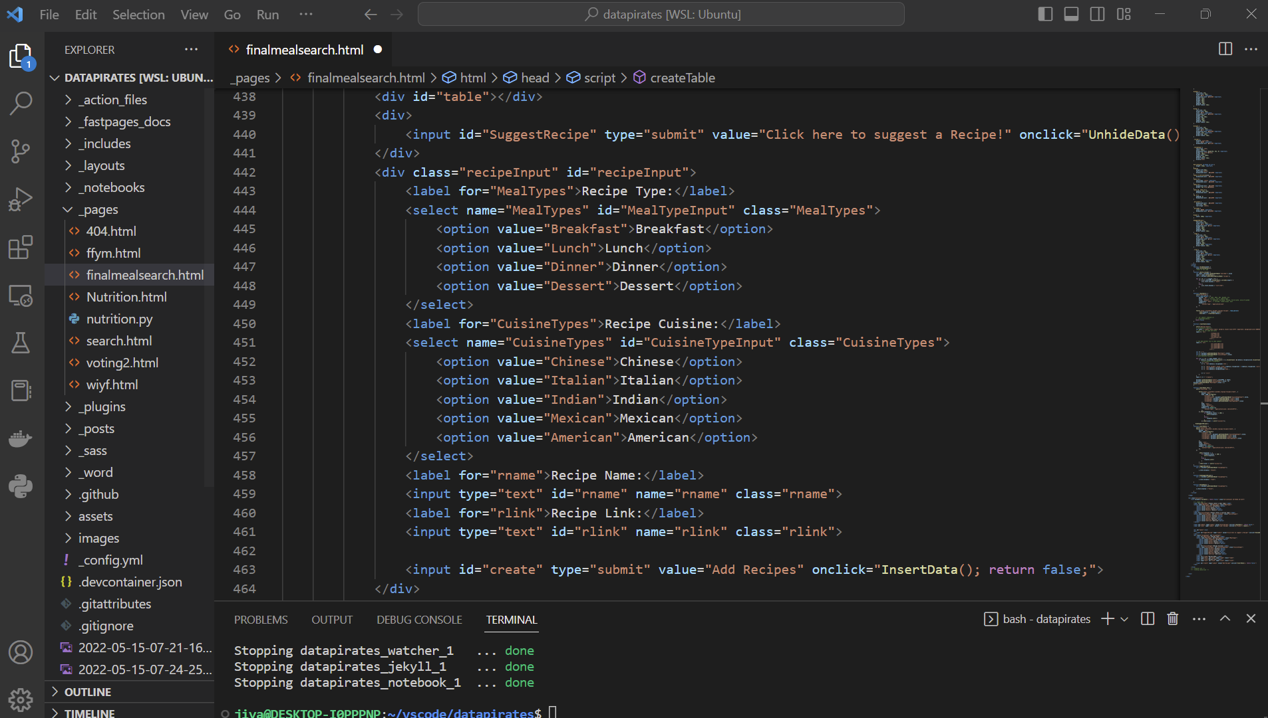

**Create + Read (see video for demonstration)**

**Error Correction + Testing (many alerts)**

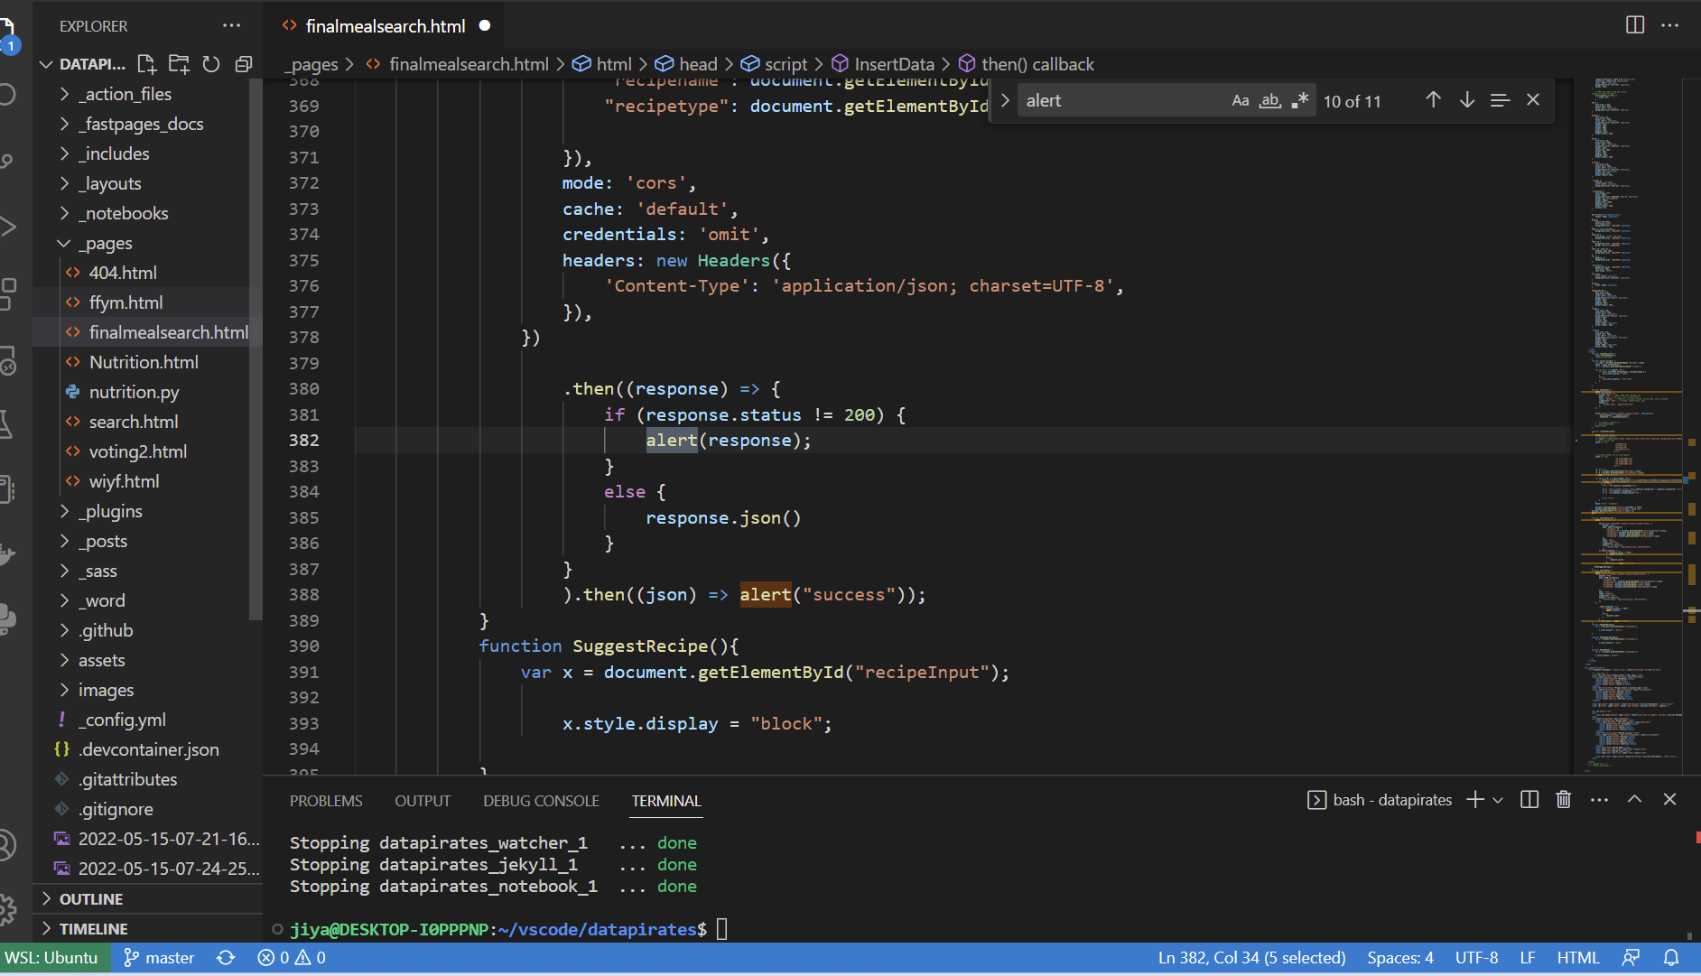

**Operations in Fastpages code that support Create + Read**

